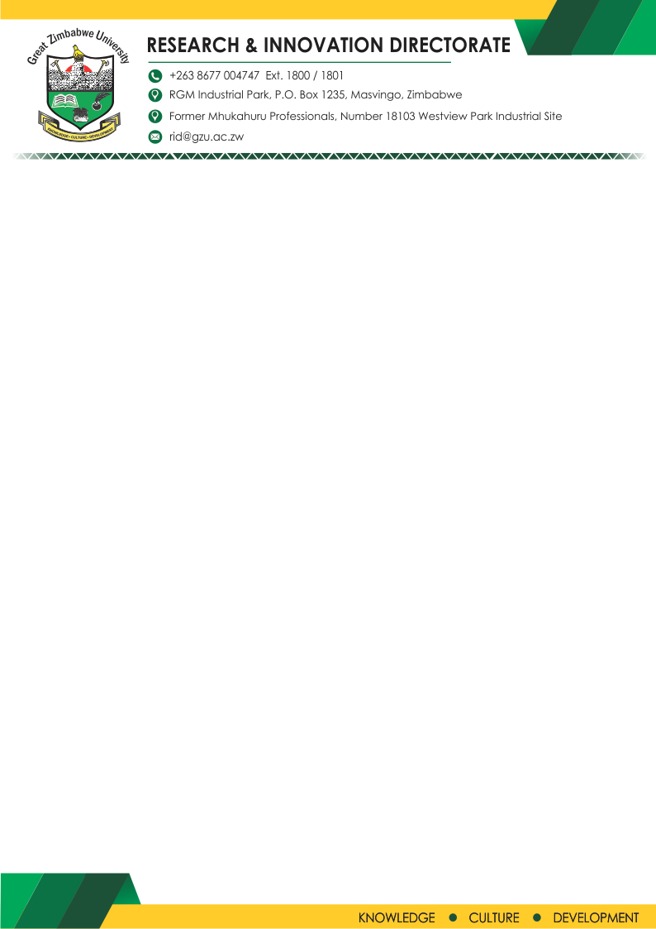

**NOTICE**

**THE RESEARCH AND INNOVATIONS CHALLENGE**

06 April 2022

**WEBINAR**

A webinar will be held to clarify key issues pertaining to this challenge including disclosing the prize money, as well as unpack the concept of innovation to all aspiring participants. ***Participation in this webinar is a prerequisite to be eligible for this Challenge.***

Please note that the webinar will be held as follows:

**Date: Wednesday 13 April 2022.**

**Time: 0930 Hours**

**Venue: Via Zoom Platform**

Join Zoom Meeting  
<https://us02web.zoom.us/j/82000618374?pwd=azBmMC9MT3JJQkloWUpmVHlsT0VyQT09>  
  
Meeting ID: 820 0061 8374  
Passcode: 343016

For more details, please follow the link : (<https://www.gzu.ac.zw/research-and-inovation/>)